United States History
EOC Review Packet
The Progressive Era

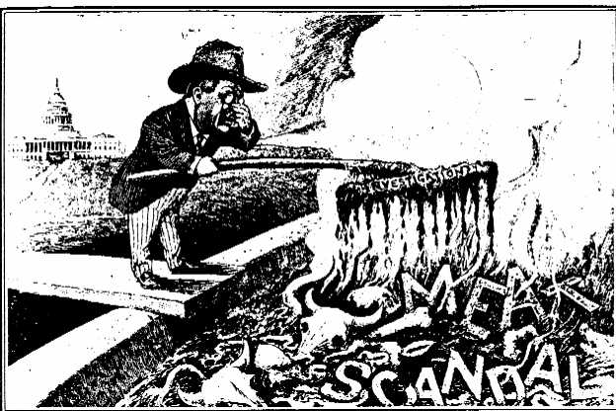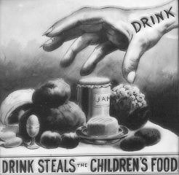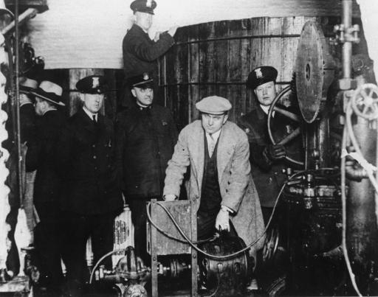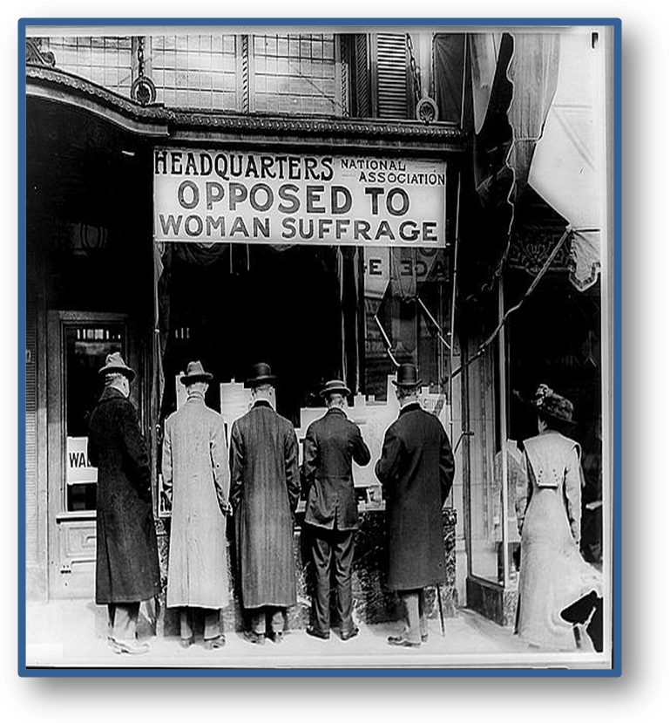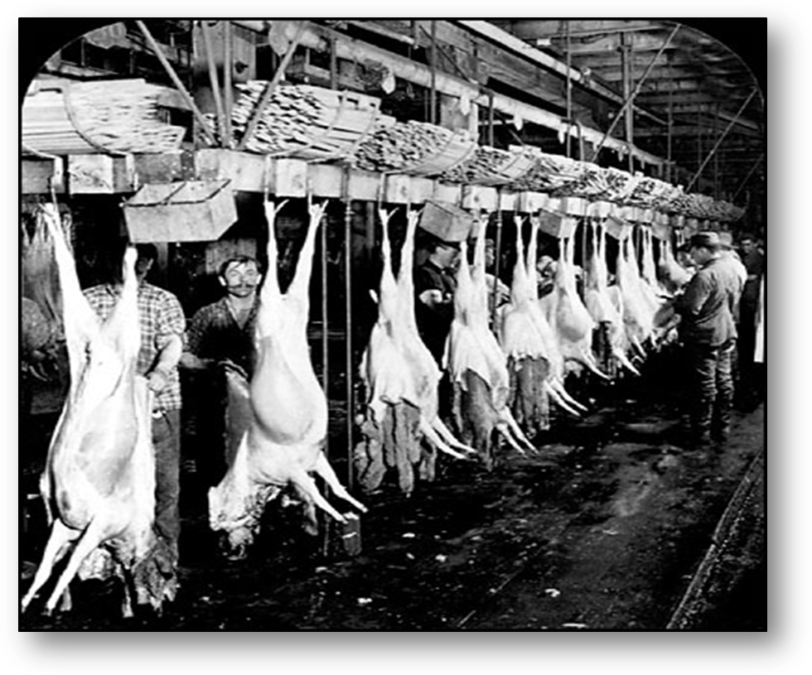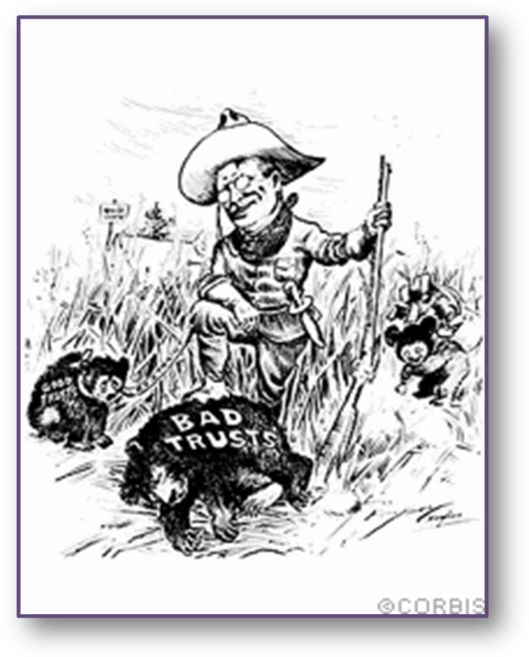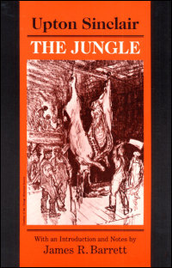

Progressive Era (Late 1800s to 1917)
- Progressive Movement: a movement to correct the economic and social abuses of industrial society. Supported consumer protection, women’s suffrage, secret ballot, income tax, direct election of Senators, Prohibition.

- Progressives: believed the government needs to regulate big business to protect consumers and workers. Opposed laissez-faire attitude of the late 19th century. The progressive movement was a response to the industrialization and urbanization of the United States because these factors led to poor, unsafe living conditions and abusive big businesses.

- Jane Addams: established settlement houses that provided assistance to the poor.

- Robert M LaFollette: progressive reformer who wanted to start a civil rights movement for African Americans (was unsuccessful).

- WEB Du Bois: formed the National Association for the Advancement of Colored People (NAACP) in order to end segregation and win equal rights.

- Booker T Washington: believed that African Americans should pursue education as the key to improving social status. Founded a vocational training institution in the late 1800s to improve economic opportunities for African Americans. Differed from WEB Du Bois on the best way that African Americans could effectively achieve equality.

- During this era, states established public schools and passed compulsory education laws. Reformers argued that an educated, literate population was necessary for a successful democracy.

- Progressive Era Economic Reform

  - Interstate Commerce Act: created the Interstate Commerce Commission. Marked the first time that a Federal regulatory agency (a branch of government that watches the economy) was established. Was passed in response to demands of farmers and small business owners.

  - Sherman Antitrust Act: law passed by congress in an attempt to limit the power of monopolies

  - Clayton Antitrust Act: declared that unions were not conspiracies in restraint of trade (made Unions legal). In response to business combinations limiting competition.

  - Gibbons v. Ogden: Supreme Court case that allowed the Federal Government to regulate interstate commerce (business and trading between different states)

  - Wabash v. Illinois: limited the power of big business

  - Federal Reserve System: established by the Federal Reserve Act (1913) which was intended to provide a stable supply of money and credit. Supported by President Woodrow Wilson. The Federal Reserve can reduce a recession by lowering interest rates.

  - Graduated/Progressive Income Tax: authorized by the 16th amendment (1913). Based on the idea that people with higher incomes should pay a greater percentage of their income in taxes (taxes are based on the ability to pay)

- Progressive Era Political Reform

  - Through laws such as initiative, referendum, recall, direct primary, and secret ballot progressives attempted to increase participation in government by citizens and involve voters more directly.

  - Direct Election of Senators: established by the 17th amendment. Citizens directly voted on who would represent them in the Senate in order to make the Senate more responsive to the people.

  - Civil Service Exams: laws were passed requiring individuals to pass tests before obtaining government jobs in order to eliminate patronage and corruption in government hiring (prevent the people in the government from hiring their friends or accepting bribes). This was a reaction to the Spoils System (officials rewarding their supporters with government jobs).

- Progressive Labor Movement/Unions

  - Labor Union: an organization of employees formed to bargain with the employer in order to get certain things such as better working conditions, benefits, and pay. Business leaders opposed the efforts of labor unions to organize and improve conditions. Clayton Antitrust Act made unions legal.

  - Collective Bargaining: discussions between labor union leaders and management (owners/bosses) to agree on a contract for workers.

  - Wagner Act: legalized collective bargaining

  - Triangle Shirtwaist Company Fire: tragedy in which many women workers were killed in a factory fire. Drew national attention to the need to protect the safety of workers.

  - Samuel Gompers: organized workers into unions in order to strive for better conditions and better pay.

  - American Federation of Labor: the first long-lasting, successful labor union in the US, because it fought for the rights of skilled workers, focused on gains in wages and working conditions, and was organized on a nationwide basis

  - Pure Food and Drug Act: law that provided federal inspection of meat products and forbade the manufacture, sale, or transportation of unsafe food products and poisonous medicines. Resulted from demands for direct consumer protection. Federal government was able to pass it because of the elastic clause.

  - Meat Inspection Act: created sanitary standards established for slaughterhouses and meat processing plants. Passed as a result of writings of muckrakers. The publication of The Jungle by Upton Sinclair led congress to pass the law.

  - Muckraker: writers during the progressive era that exposed social ills of inner cities, factory conditions, and political corruption. Focused on issues including the monopoly of Standard Oil, cattle processing, meat packing, child labor, and wages. Examples: Upton Sinclair, Ida M Tarbell, Lincoln Steffens, Jacob Riis

  - Populist Party: a political coalition of farming interests directed against banking and railroads

    - a third party that eventually disappeared but proposed ideas that later became law
    - expressed the discontent of many farmers with their ongoing economic problems
    - proposed the national income tax, free and unlimited coinage of silver, direct election of senators, government ownership of railroads. Supported antitrust laws
    - similar to the Progressive Party because both opposed the strict laissez-faire attitudes of the federal government, and both wanted the use of Federal power to correct social and economic problems

  - Granger Movement: wanted to force railroads to lower freight fates. Wanted to pass laws increasing Federal regulation of monopolies. Supported by farmers in the west.

- Theodore Roosevelt

  - New Nationalism: policy designed to help the US solve problems caused by industrialization

  - Square Deal: increased the role of the Federal Government in dealing with social and economic problems

  - Trust Busting: had policies that encouraged competition in business by attacking monopolies, trusts, pools, etc. Became known as the Trustbuster. Believed the government should regulate big business.

  - Big Stick Policy: “Walk softly but carry a big stick.” Policy that was used by the US to police the Western Hemisphere and intervene in Latin American affairs. Wanted to prevent the extension of European control over Latin America.

  - Expanded the Monroe Doctrine: claimed the Monroe Doctrine permits the US to intervene actively in the affairs of Latin American nations

  - US influence in the Caribbean Sea region is significantly increased as a result of Roosevelt’s policies

  - Helped negotiated the end of the Russo-Japanese War (war between Russia and Japan)



